1. FORECAST FUTURE SALES

Introduction

Time series is a sequence of observations recorded at regular time intervals. Depending on the frequency of observations, a time series may typically be hourly, daily, monthly, quarterly and annual.

To gain some useful insights from time series data, you must decompose the time series and look for some basic components such as trend seasonality, cyclic behavior, and irregular fluctuations. Based on some of these behaviors, we are deciding on which model to choose for time series modelling.

Stationary

Stationary means that the statistical properties of a process generating a time series do not change over time. It is statistical properties (mean, variance, standard deviation) remain constant over time.

Check Stationary of the Dataset

We can assume the series to be stationary if it has constant statistical properties over time

* constant mean
* constant variance
* an autocovariance that does not depend on time

We check the stationary using the:

**Plotting Rolling Statistic:** plot the moving average or moving variance and see if it varies time.

**Dickey- Fuller Test:** if the test statistic is less than the critical value, we can reject the null hypothesis and say that the series is stationary.

Dickey fuller test results:

Test Statistic 1.705736

p-value 0.998143

#Lags Used 10.000000

Number of Observations Used 26.000000

Critical Value (1%) -3.711212

Critical Value (5%) -2.981247

Critical Value (10%) -2.630095

Since the p-value, is not less than 0.05 we fail to reject the null hypothesis. This means the time series is non-stationary.

In the other words, it has some time-dependent structure and does not have constant variance over time.

Make a Time series Stationary

* Take a log transform
* Moving average
* Exponentially weighted moving average
* Difference
* Decomposition

1. Log Transform

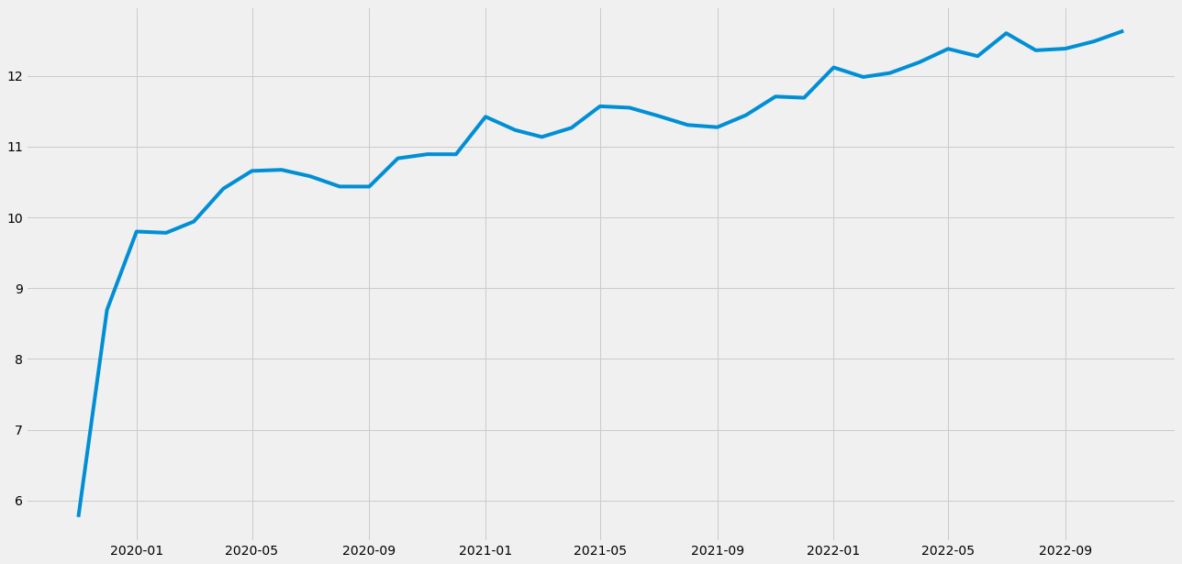

Figure 1‑1

1. Moving Average

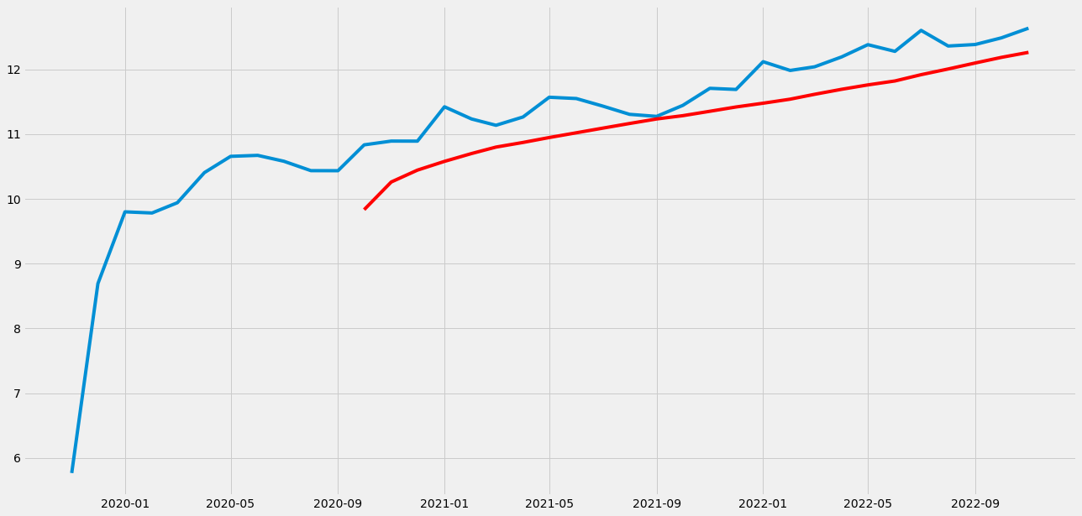

Figure 1‑2

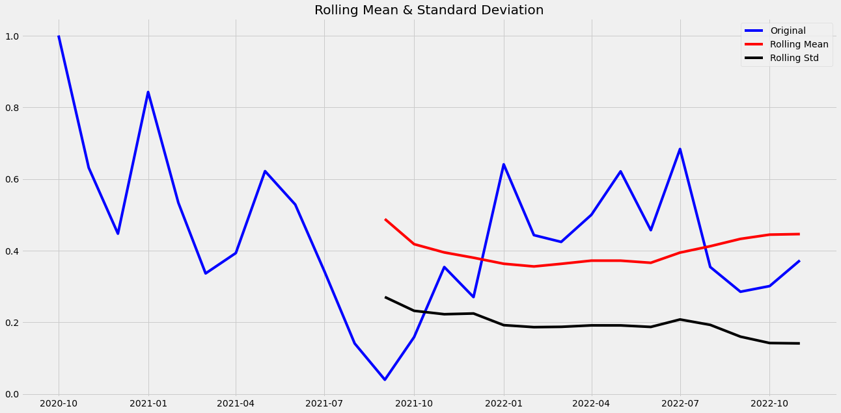

Figure 1‑3

Results of Dickey-Fuller Test:

Test Statistic -3.064405

p-value 0.029302

#Lags Used 9.000000

Number of Observations Used 16.000000

Critical Value (1%) -3.924019

Critical Value (5%) -3.068498

Critical Value (10%) -2.673893

1. **Exponentially weighted moving average**

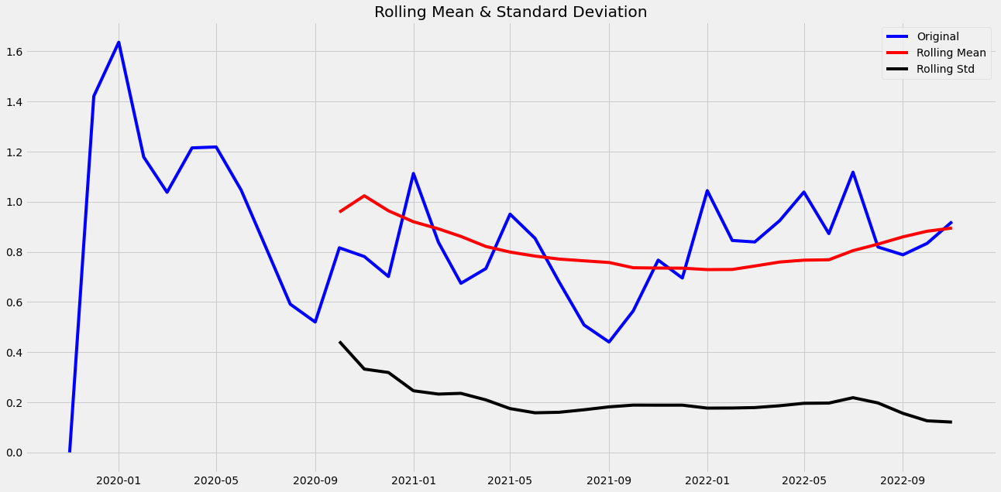

Figure 1‑4

Results of Dickey-Fuller Test:

Test Statistic -4.934859

p-value 0.000030

#Lags Used 0.000000

Number of Observations Used 36.000000

Critical Value (1%) -3.626652

Critical Value (5%) -2.945951

Critical Value (10%) -2.611671

1. **Difference**

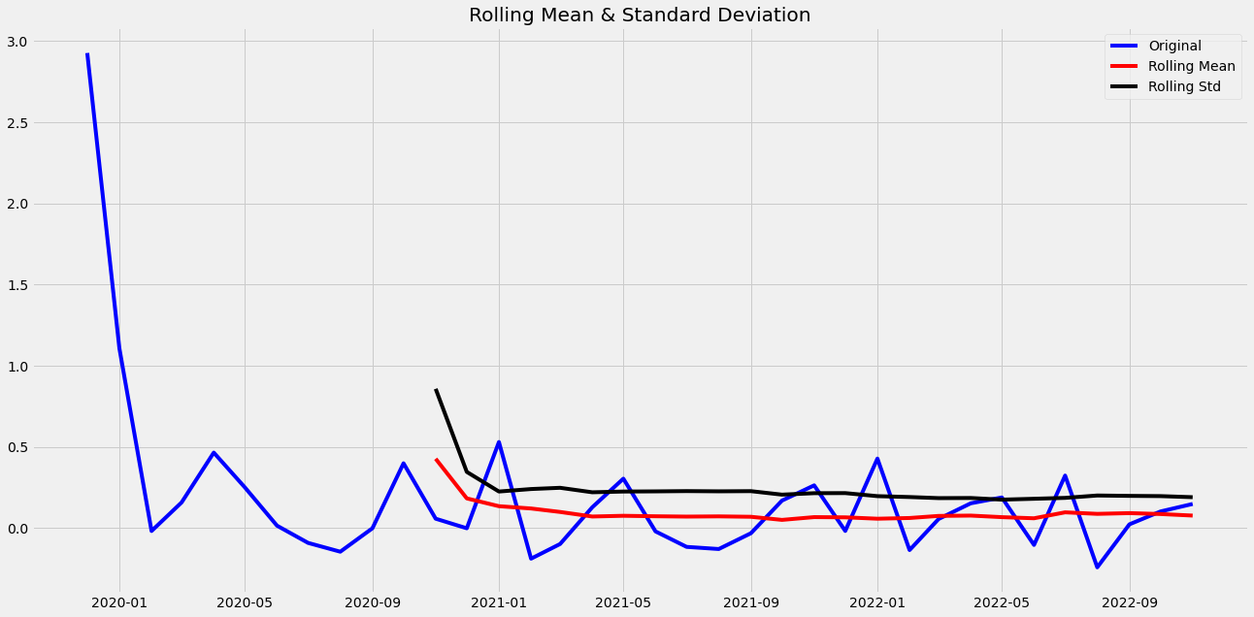

Figure 1‑5

Results of Dickey-Fuller Test:

Test Statistic -1.049268e+01

p-value 1.136276e-18

#Lags Used 0.000000e+00

Number of Observations Used 3.500000e+01

Critical Value (1%) -3.632743e+00

Critical Value (5%) -2.948510e+00

Critical Value (10%) -2.613017e+00

1. **Decomposition**

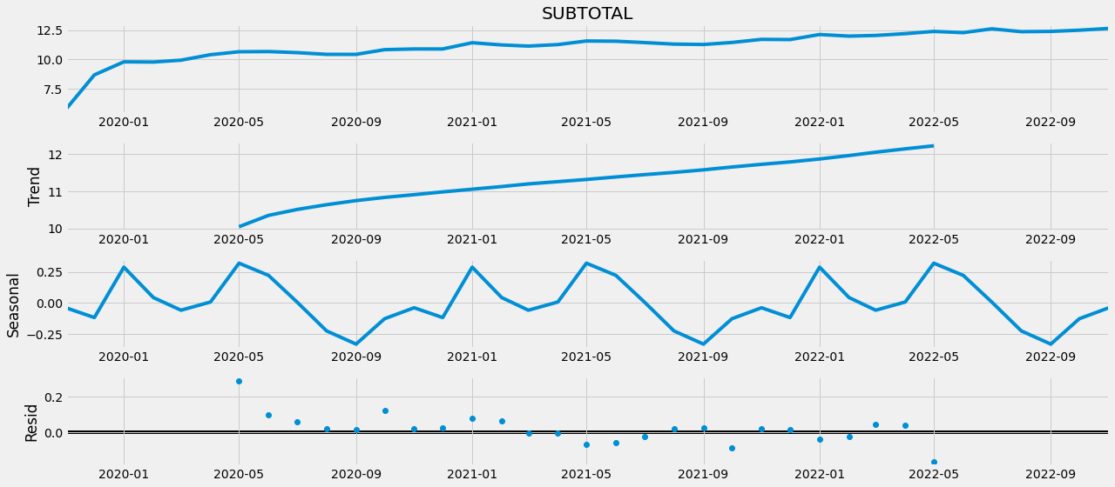

Figure 1‑6

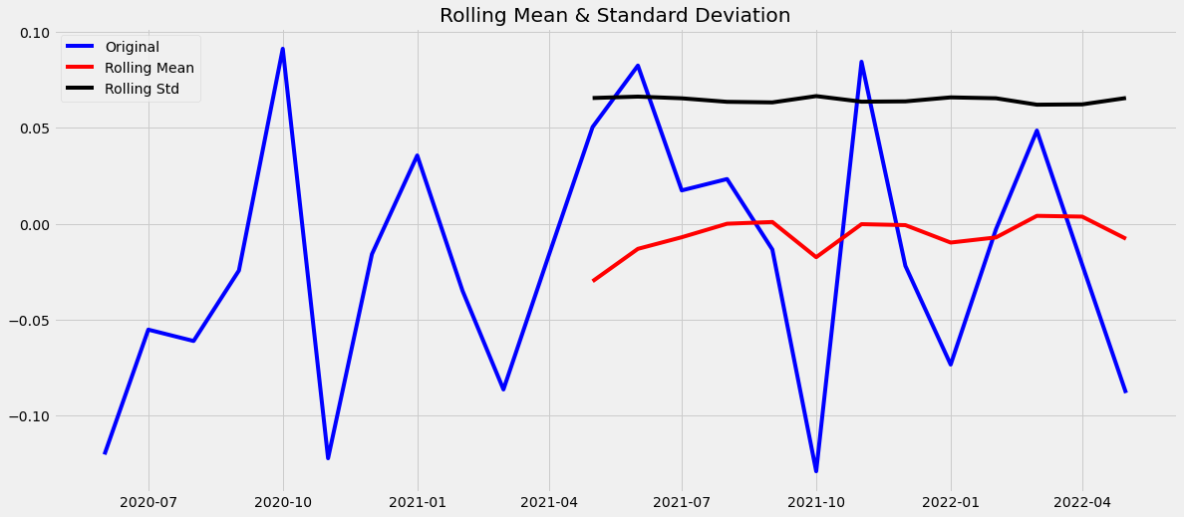

Figure 1‑7

Results of Dickey-Fuller Test:

Test Statistic -5.061432

p-value 0.000017

#Lags Used 0.000000

Number of Observations Used 23.000000

Critical Value (1%) -3.752928

Critical Value (5%) -2.998500

Critical Value (10%) -2.638967

ARIMA

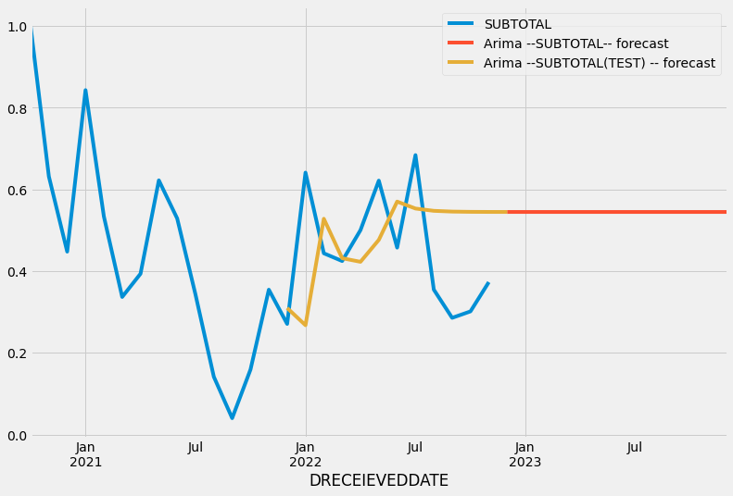

Figure 1‑8

r2_score: -1.0514512338788533

mae: 0.18534852722341932

mse: 0.03726852842423262

rmse: 0.19305058514346085

**SARIMAX MODEL**

The SARIMAX model (Seasonal Auto-Regressive Integrated Moving Average with eXogenous factors) is an improved version of the ARIMA model. ARIMA incorporates an autoregressive integrated moving average, whereas SARIMAX incorporates seasonal effects and eXogenous factors in addition to the autoregressive and moving average components.

**Trend Elements**

There are three trend elements that require configuration.

They are the same as the ARIMA model; specifically:

* **p**: Trend autoregression order.
* **d**: Trend difference order.
* **q**: Trend moving average order.

**DATA SET PREPARATION FOR THE MODEL**

First of all the required libraries were imported from the python packages.

import matplotlib.pyplot as plt  
import seaborn as sns  
import warnings  
warnings.filterwarnings("ignore")  
pd.set_option('display.float_format', lambda x: '%.2f' % x)  
from statsmodels.tsa.statespace.sarimax import SARIMAX  
from statsmodels.graphics.tsaplots import plot_acf,plot_pacf  
from statsmodels.tsa.stattools import adfuller  
from statsmodels.tsa.seasonal import seasonal_decompose   
from pmdarima import auto_arima   
from sklearn.metrics import mean_squared_error  
from statsmodels.tools.eval_measures import rmse  
import pmdarima as pm  
import warnings  
warnings.filterwarnings("ignore")

warnings.filterwarnings("ignore")

Our main dataframe has been read by pandas library and defined as ‘df’ variable.

Index column for SARIMAX model must be date or datetime column. The model makes the forecasting on datetime basis.

df = pd.read_csv('/kaggle/input/satislar.csv',parse_dates = True, index_col = 'DRECEIEVEDDATE')

Numeric columns like ’SUBTOTAL’ was selected to build SARIMAX model. The reason of seperation of dataframes, is the way of working SARIMAX model. Because the model requires only one dimensional dataframes.

df_subtotal = df[['SUBTOTAL']]

df_subtotal.plot(figsize=(12,8));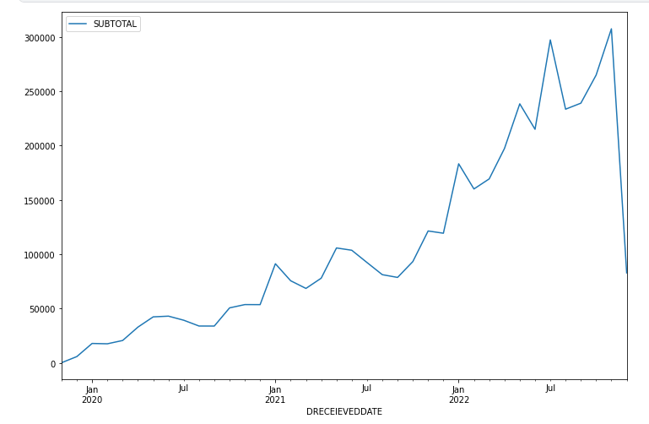

Figure 1‑9

df['DRECEIEVEDDATE'].max()

Result:  
' 9.12.2022 '

As the plot shows above, the data is slumping at the last value on ‘DRECEIVEDATE’ the reason for that, is the last month has not been completed. The last day of the last month was shown as ’09.12.2022’. In this case, it was decided to drop the data of the last month, as the Sarimax model would be more difficult to predict.

Below the last value of the dataframe were dropped.

df_subtotal.drop(df_subtotal.index[-1],inplace=True)

**MODELLING**

**1.Subtotal**

Subtotal value mentions the amount without tax on sales. In other words, it may be called the sales price without tax.

The dataframe fixed on the first day of the month and sum of ‘SUBTOTAL’ values were resampled on dataframe. So it is calculated monthly ‘SUBTOTAL’ values.

df_subtotal = df_subtotal.resample('MS').sum()

**Result of Resampling(SUBTOTAL):**

tablo içeren bir resim

Açıklama otomatik olarak oluşturuldu

Figure 1‑10

Sarimax_model = auto_arima(df_subtotal,  
 start_P=1,  
 start_q=1,  
 max_p=3,  
 max_q=3,  
 m=12,  
 seasonal=True,  
 d=None,  
 D=1,  
 trace=True,  
 error_action='ignore',  
 suppress_warnings=True,  
 stepwise=True)  
Sarimax_model.summary()

‘Auto_Arima’ function is the function under the SARIMAX library to give the best parameters for the future forcasting.

Start_p refers to the starting value of P , the order of the auto-regressive portion of the seasonal model.

Star_q refers to The starting value of q , the order of the moving-average portion of the seasonal model.

Max_p refers to The maximum value of p, inclusive. Must be a positive integer greater than start_p.

Max_q refers to The maximum value of Q, inclusive. Must be a positive integer greater than start_q.

Parameter ‘M’ refers to The period for seasonal differencing, to the number of periods in each season. For example, m is 4 for quarterly data, 12 for monthly data, or 1 for annual (non-seasonal) data. Default is 1. Note that if m == 1 (i.e., is non-seasonal), seasonal will be set to False. For more information on setting this parameter, see [Setting m](https://alkaline-ml.com/pmdarima/tips_and_tricks.html#period).

Parameter ‘seasonal’ refers to Whether to fit a seasonal ARIMA. Default is True. Note that if seasonal is True and m == 1, seasonal will be set to False.

Parameter ‘d’ The order of first-differencing. If None (by default), the value will automatically be selected based on the results of the test (i.e., either the Kwiatkowski–Phillips–Schmidt–Shin, Augmented Dickey-Fuller or the Phillips–Perron test will be conducted to find the most probable value). Must be a positive integer or None. Note that if d is None, the runtime could be significantly longer.

Parameter ‘D’ refers to The order of the seasonal differencing. If None (by default, the value will automatically be selected based on the results of the seasonal_test. Must be a positive integer or None.

Parameter ‘trace’ refers to Whether to print status on the fits. A value of False will print no debugging information. A value of True will print some. Integer values exceeding 1 will print increasing amounts of debug information at each fit.

Parameter ‘error_action’ refers to If unable to fit an ARIMA for whatever reason, this controls the error-handling behavior. Model fits can fail for linear algebra errors, convergence errors, or any number of problems related to stationarity or input data.

* ‘warn’: Warns when an error is encountered (default)
* ‘raise’: Raises when an error is encountered
* ‘ignore’: Ignores errors (not recommended)
* ‘trace’: Logs the entire error stacktrace and continues the

search. This is the best option when trying to determine why a model is failing.

Parameter ‘suppress_warnings’ refers to Many warnings might be thrown inside of statsmodels. If suppress_warnings is True, all of the warnings coming from ARIMA will be squelched. Note that this will not suppress UserWarnings created by bad argument combinations.

Parameter ‘stepwise’ refers to The stepwise algorithm can be significantly faster than fitting all (or a random subset of) hyper-parameter combinations and is less likely to over-fit the model.

**Results of auto_arima_subtotal:**

**tablo içeren bir resim

Açıklama otomatik olarak oluşturuldu**

Figure 1‑11



* 1. **Fitting the model_subtotal**

With the code below, it is build to fit ‘SARIMA’ model.

model_subtotal = SARIMAX(df_subtotal,order=(1, 1, 0),  
 seasonal_order=(0, 1, 0, 12),  
 enforce_stationarity=False,  
 enforce_invertibility=False)  
results_subtotal = model_subtotal.fit()

Wıth the code below, the forecast is operated for the next 12 months on dataset. It is given the start and end dates over the lenght of the dataset and the forecasting was made with predict function. Additonally, it is created a test model to get insight for the model performance.

forecast_subtotal = results_subtotal.predict(start = len(df_subtotal),end=len(df_subtotal)+12,typ='levels').rename('Arima --SUBTOTAL-- forecast')

forecast_subtotal_test = results_subtotal.predict(start = len(df_subtotal)-12,end=len(df_subtotal),typ='levels').rename('Arima --SUBTOTAL(TEST) -- forecast')

The code belove is plotting the previous subtoal values and forecasted subtotal values.

df_subtotal.plot(figsize=(12,8),legend=True)

forecast_subtotal.plot(legend=True);

forecast_subtotal_test.plot(legend=True)

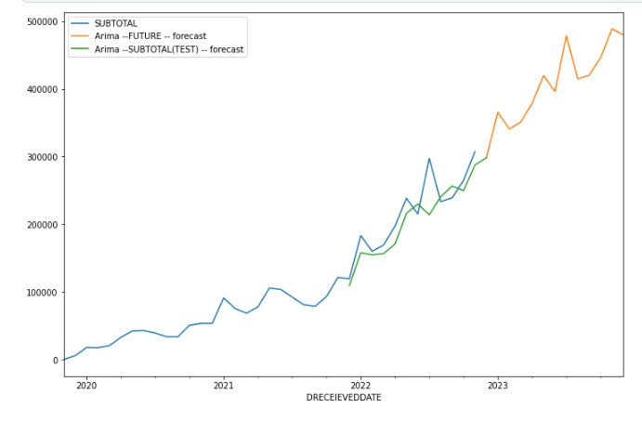

Figure 1‑12

print(forecast_subtotal)

metin içeren bir resim

Açıklama otomatik olarak oluşturuldu

Figure 1‑13

print(forecast_subtotal_test)

tablo içeren bir resim

Açıklama otomatik olarak oluşturuldu

Figure 1‑14

**1.2 Test Forecasting of the model**

tablo içeren bir resim

Açıklama otomatik olarak oluşturuldu

Figure 1‑15

df_subtotal_tail['Forecast Difference Percentage'].mean()

**Result:**



When the performance of the model was evaluated, it was observed that there was an average of 9% difference between the actual and predictive values ​​of the model.

eval_metric(df_subtotal_tail['SUBTOTAL'],df_subtotal_tail['Arima --SUBTOTAL(TEST) -- forecast'])

**Result:**

metin içeren bir resim

Açıklama otomatik olarak oluşturuldu

Considering the predictive power and R2 scores of the model, the model made predictions with an r2 score of 0.75. R2 score close to 1 indicates that the prediction is accurate and strong.

**1.3 Future Forecasting of the model**

The future predictions made by the SARIMAX modeling are given as follows.

metin, tablo içeren bir resim

Açıklama otomatik olarak oluşturuldu

Figure 1‑16

It is also obtained from the model evaluation results that the model will have a certain margin of error on the predictions made. The estimation covers December of 2022 and December of 2023.

**2. ANOVA TEST**

Is there a difference between the average monthly sales amounts on the sales platforms?

Introduction

There are some statistical tests to see if there is a difference between monthly sales averages. Since there are more than 2 groups here, we decided to apply ANOVA Test. The one-way ANOVA tests the null hypothesis that two or more groups have the same population mean. The test is applied to samples from two or more groups, possibly with differing sizes.

The ANOVA test tells if there is a difference between the averages. If there is, it does not say between which groups.

In order to apply ANOVA test to a data, the following 6 conditions must be fulfilled:

1. The dependent variable must be continuous.

2. The independent variable must be categorical.

3. The number of groups must be at least 2.

4. The sample must have a normal distribution.

5. The variance of the groups must be homogeneous.

6. Observations should be randomly selected.

Here, the top 5 platforms with the most sales were selected.

tablo içeren bir resim

Açıklama otomatik olarak oluşturuldu

Figure 2‑

The sum of each platform's monthly sales is assigned to a list.

metin içeren bir resim

Açıklama otomatik olarak oluşturuldu

Figure 2‑2

Shapiro-Wilk test for Normality

The Shapiro-Wilk test tests the null hypothesis that the data was drawn from a normal distribution.

metin içeren bir resim

Açıklama otomatik olarak oluşturuldu

Figure 2‑3

Since the p-value for all groups is >0.05, the null hypothesis cannot be rejected (normality assumption is valid). There is a normal distribution.

Homogeneity with Bartlett's Test for Equal Variances

Bartlett's test tests the null hypothesis that all input samples are from populations with equal variances. For samples from significantly non-normal populations, Levene's test levene is more robust.

metin içeren bir resim

Açıklama otomatik olarak oluşturuldu

Figure 2‑4

Here, it was concluded that the group variances were not homogeneous because the p-value was less than 0.05.

Let's look at the top 3 platforms with high sales

metin içeren bir resim

Açıklama otomatik olarak oluşturuldu

Figure 2‑5

p-value again less than 0.05. These 5 groups do not meet the homogeneity of ANOVA test conditions. Let's look at the first two platforms.

metin içeren bir resim

Açıklama otomatik olarak oluşturuldu

Figure 2‑6

Since the P-value is >0.05, the variances of Amazon and Website groups are homogenous. If we apply one-way ANOVA test to these two groups

metin içeren bir resim

Açıklama otomatik olarak oluşturuldu

Figure 2‑7

The one-way ANOVA tests the null hypothesis that two or more groups have the same population mean. P-value < 0.05, the h0 hypothesis is rejected. This means that the groups do not have the same population mean.

metin içeren bir resim

Açıklama otomatik olarak oluşturuldu

Figure 2‑8

When we compare Etsy and Amazon FBA groups, one-way ANOVA test shows us that the average monthly sales of these two platforms are close to each other.

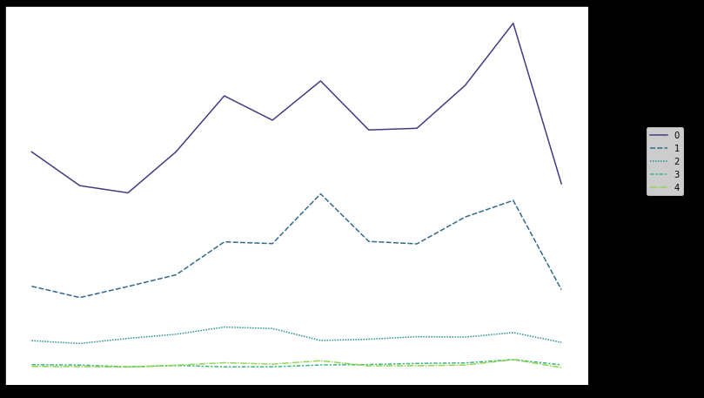

0. Amazon

1. WEB

2. Ebay

3. Etsy

4. Amazon FBA

Figure 2‑9

**3. INCOME ANALYSIS WITH TABLEAU**

**1. Determining Whether There Are Breaks In the Monthly Turnover Values**

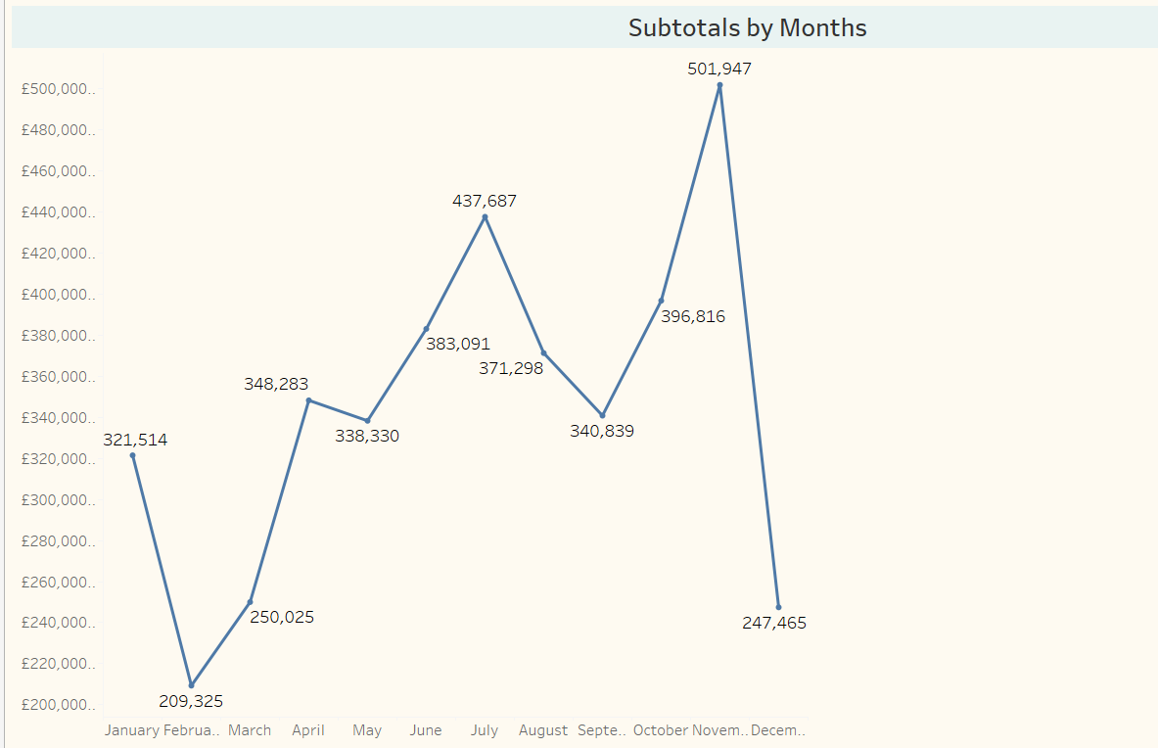

Figure 3-1

It is observed that there are decreases in the product turnover in January. In February and March, it is observed that the rise continues, but between April and May there is a situation that can be said to be partially sellable. After May, it is seen that the rise continues until July. A decrease is observed in July and August. However, the rise continued from September to December. It is seen that there is a serious decrease in December. The reason for this is thought to be due to the fact that the dataset we have contains the latest data dated December 9th. In fact, since there is no data on the whole month, a healthy evaluation cannot be made.

**Comment:** The reason for the decrease in July and August; It is considered that the reason for the rise from September to December may be due to the high season.

**2. Determining Whether There is a Break in The Turnover Values of The Months of Each Year**

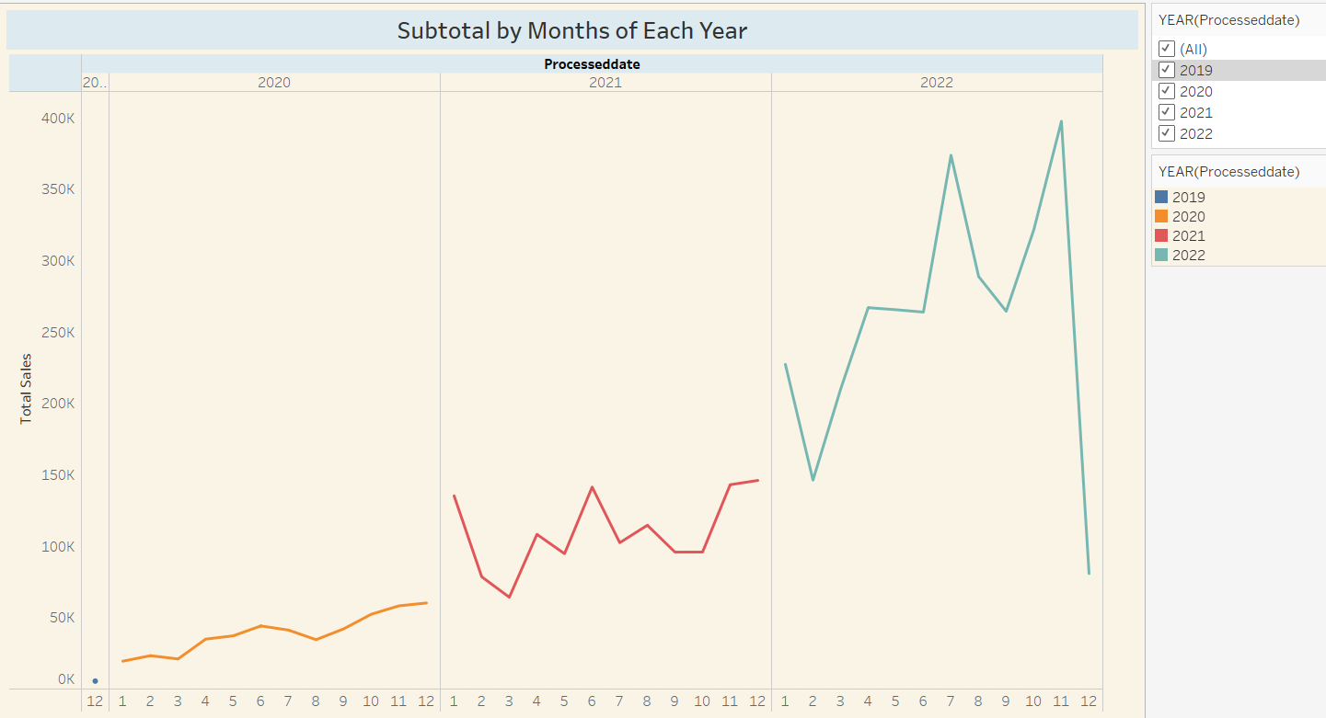

Figure 3-2

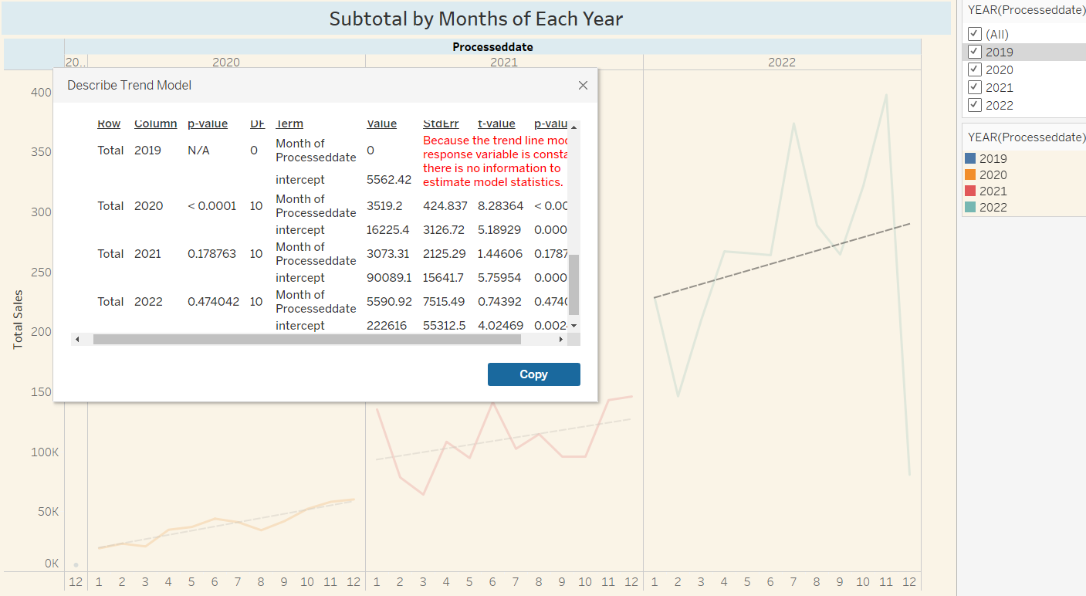

Figure 3-3

Since sales started in December 2019, 2019 was not included in the evaluation. When the graph is analyzed, while a linear sales trend is observed in 2020, slight ups and downs are observed in 2021. However, although there are sharp ups and downs in sales for 2022, there is a similarity between 2021 and 2022. When we examine the p-value values for 2021 and 2022, it is understood that there is no significant difference between the sales of these two years.

**3. Causality Analysis: Effect of War on Sales, Inflation in Turkey, Expectation in Turkish exchange rate, Covid-19 etc.)**

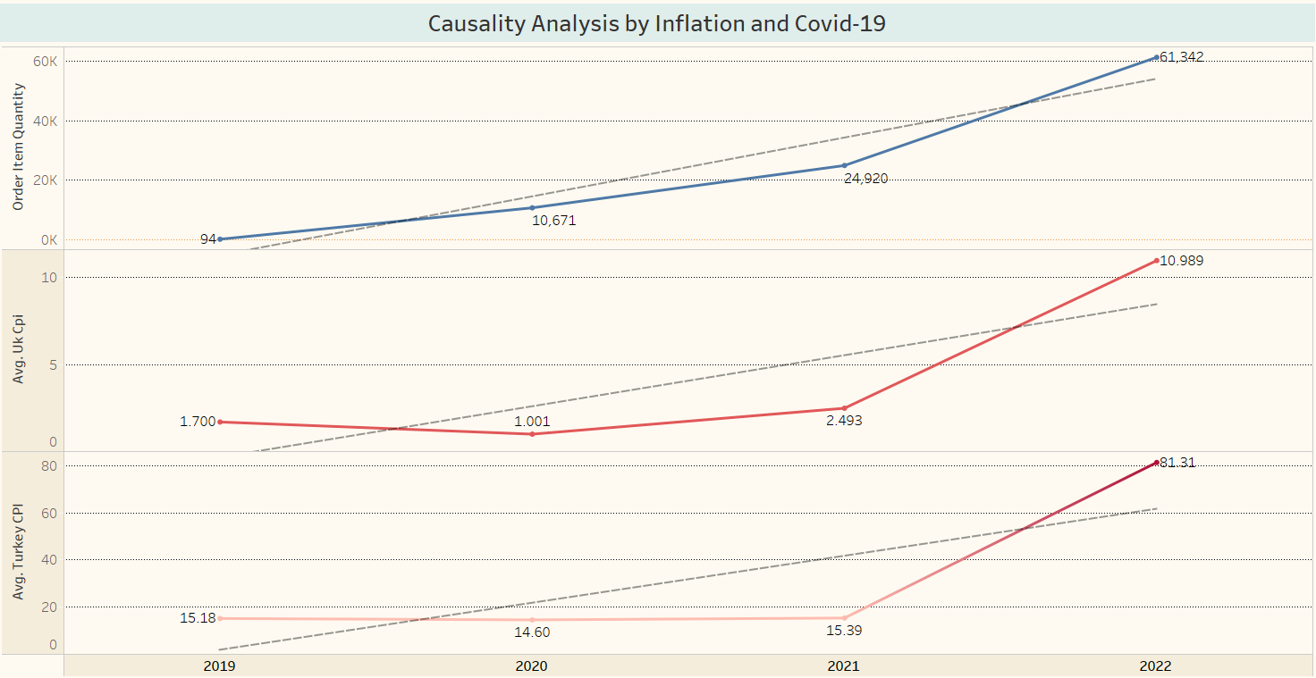

Figure 3-4

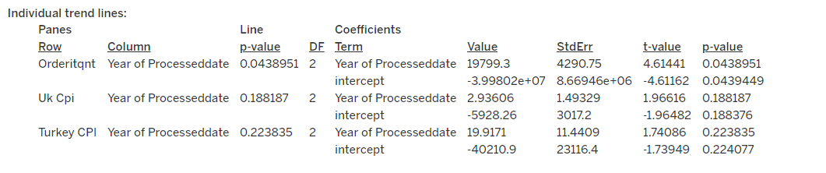

Figure 3-5

As can be seen in the above trend-line chart, the p-value of the order item quantity is 0.043, the p-value of the United Kingdom's inflation feature is 0.18, and the p-value of Turkey's inflation feature is 0.22. According to this result, it is understood that there is no significant difference between the annual average inflation values between Turkey and the United Kingdom and the orders received over the years.

**4. Is there a difference between the average monthly sales amounts on the sales platforms? (A/B Analysis)**

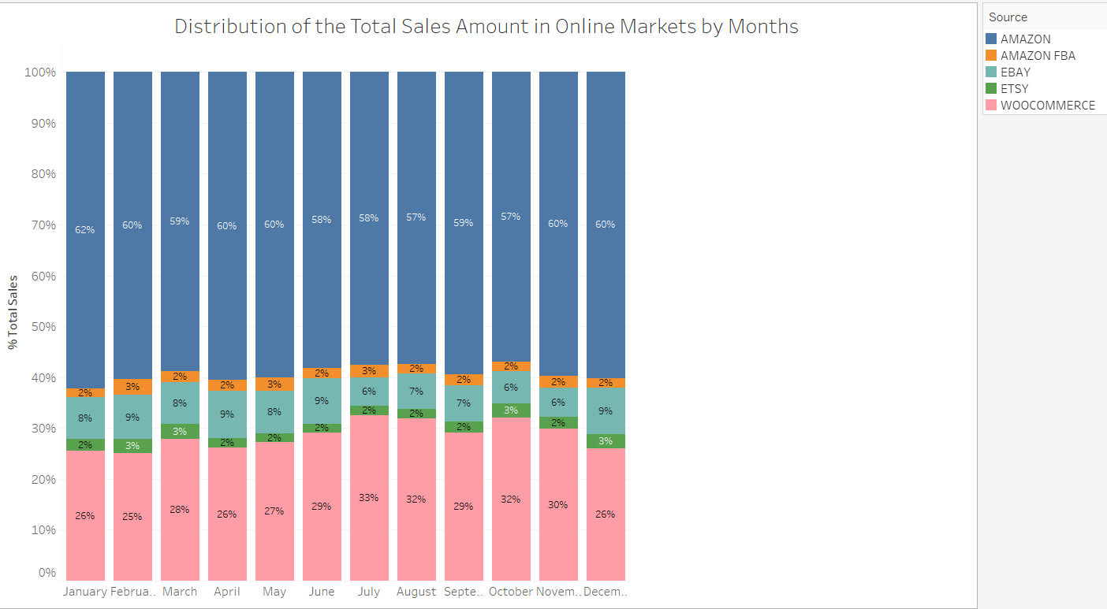

Figure 3-6

In the A-B Analysis; It is seen that the highest monthly sales in online markets are made on Amazon with a range of 57%-62%, Woocommerce as the second with a range of 26-33%, and EBAY as the third with a range of 6%-9%. Monthly sales on Amazon FBA and ETSY vary between 2% and 3%.

**5. In the light of Time Series Analysis, the maximum profitability that can be obtained in the sales to be made within the next six months**

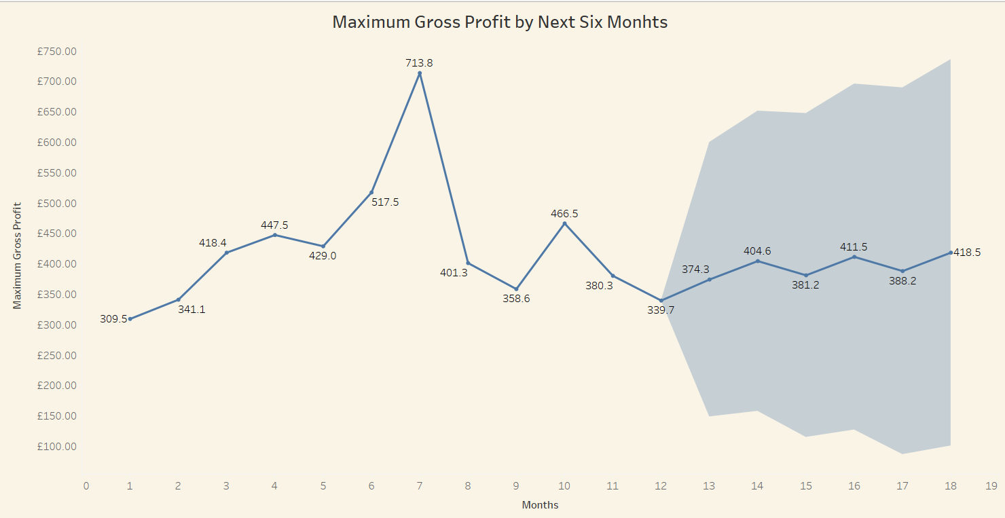

Figure 3-7

**Describe Forecasts**



Figure 3-8

Maximum profitability is expected to continue “poorly” over the next 6 months.

**6. Similarity of sales volumes of sales platforms (Effect Size Analysis)**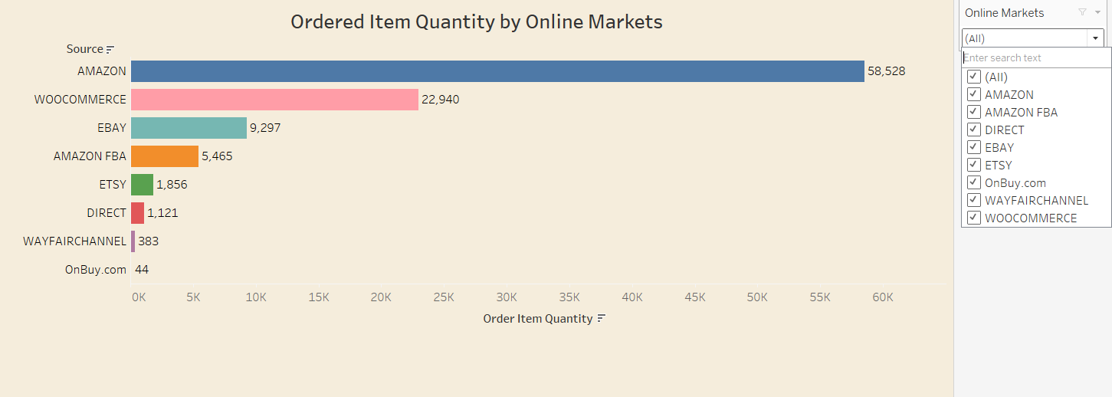

Figure 3-9

In online markets; Amazon is in the first place with 58528 sales, in the second place is Woocommerce with 22940 sales, followed by EBAY, Amazon FBA, ETSY and others. Sales volumes differ according to sales platforms.

**7. UK Monthly Sales Changes**

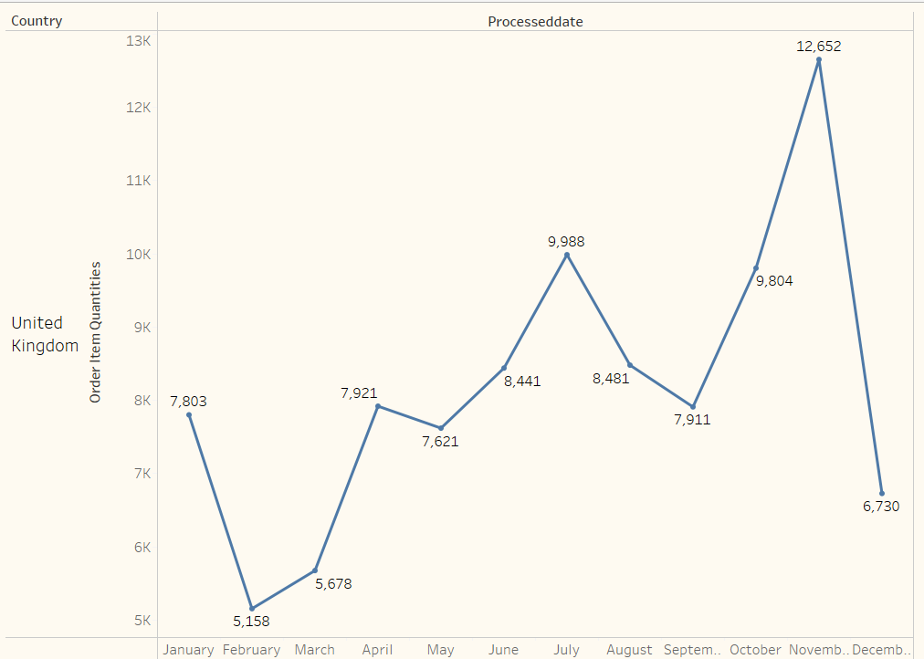

Figure 3-10

Ingilteredeki urun satislari ile aylik ciro arasinda benzerlik gozlemlenmektedir. Ocak ayinda dusus yasandigi, subat ve mart aylarinda ise, yukselisin devam ettigi ancak nisan ve mayis aylari arasinda kismen satabil denilebilecek bir durum yasandigi gozlenmektedir. Mayis ayindan sonra, temmuz ayina kadar yukselisin devam ettigi fakat temmuz ve agustos aylarinda dusus yasandigi gorulmektedir. Buna mukabil, eylul ayindan itibaren aralik ayina kadar yukselis devam ettigi gorulmektedir. Aralik ayinda ise, ciddi bir dusus yasandigi gozlenmektedir.

**Comment:** The reason for the decrease in July and August; since it is a holiday season, it is considered that the reason for the rise from September to December may be due to the high season. The reason for the decrease in sales in December is considered to be due to the fact that the dataset we have contains the latest data dated December 9th. In fact, since there is no data on the whole month, a healthy evaluation cannot be made.

**8. Monthly Sales Trends (Line Graph)**

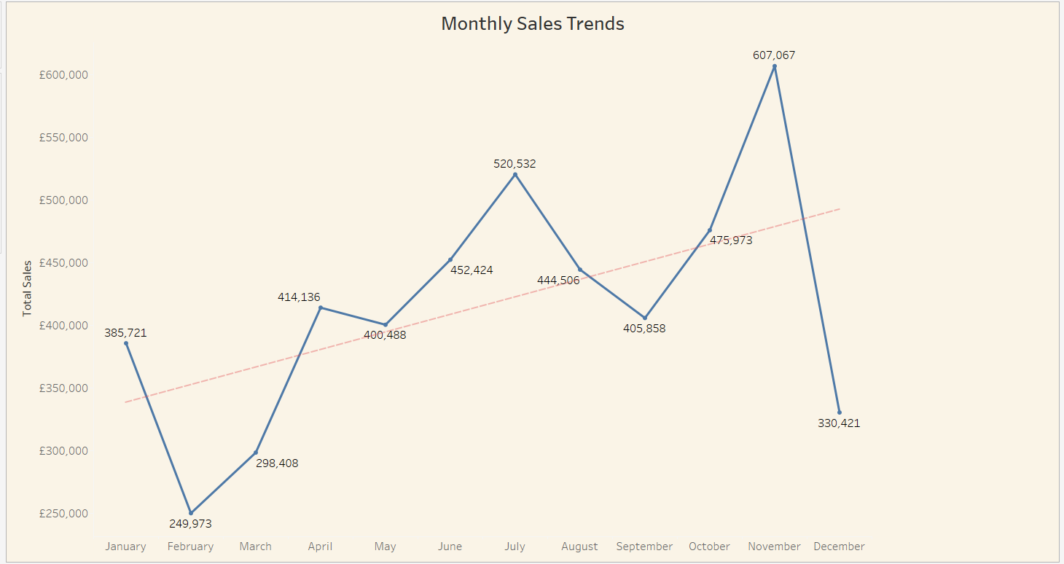

Figure 3-11

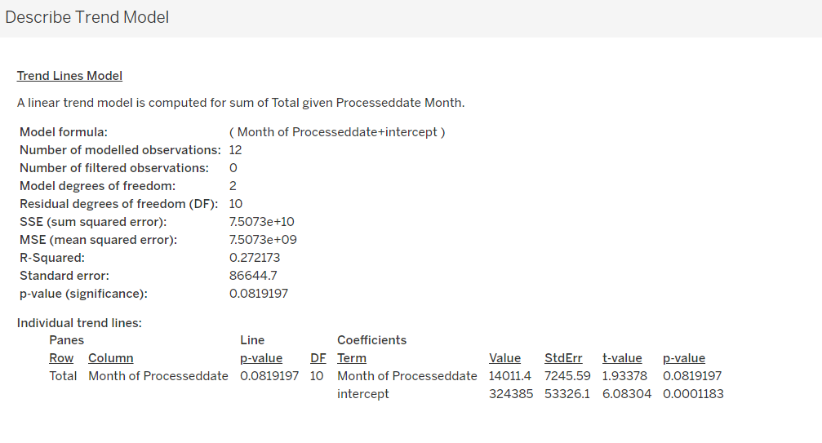

Figure 3-12

The P-value is seen as 0.081. Since this value is greater than 0.05, it shows that there is a significant difference between monthly sales trends.

**9. Distribution of Orders, Sales and Profits in the UK**

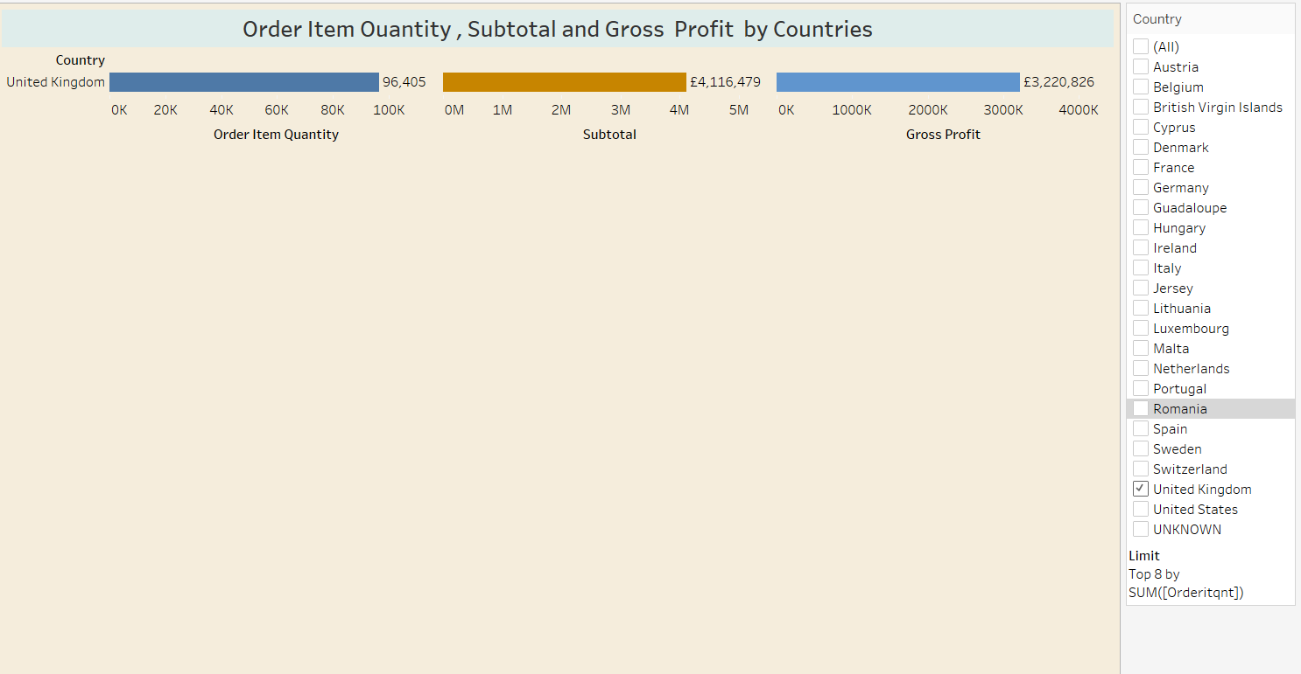

Figure 3-13

**Distribution of Order, Sales and Profits in the Top 8 Countries Except UK**

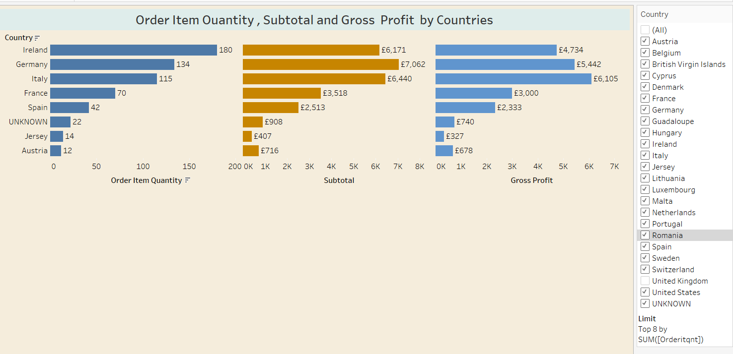

Figure 3-14

There are eight countries where the company receives the highest number of orders after the UK. Since the order numbers of other countries are 1, they are not shown in this chart. In these countries; when the number of orders, sales and gross profits are examined, it is seen that there is a correct ratio in countries other than the first 3 countries. For example, although the number of orders in Ireland is more than Germany and Italy, it is understood that the subtotal and profit are less than these countries. From these results, it can be understood that the carpet preference of the countries varies according to the price and the type of carpet.

**10. Reklam Harcamaları ve Gelir Arasindaki Iliski**

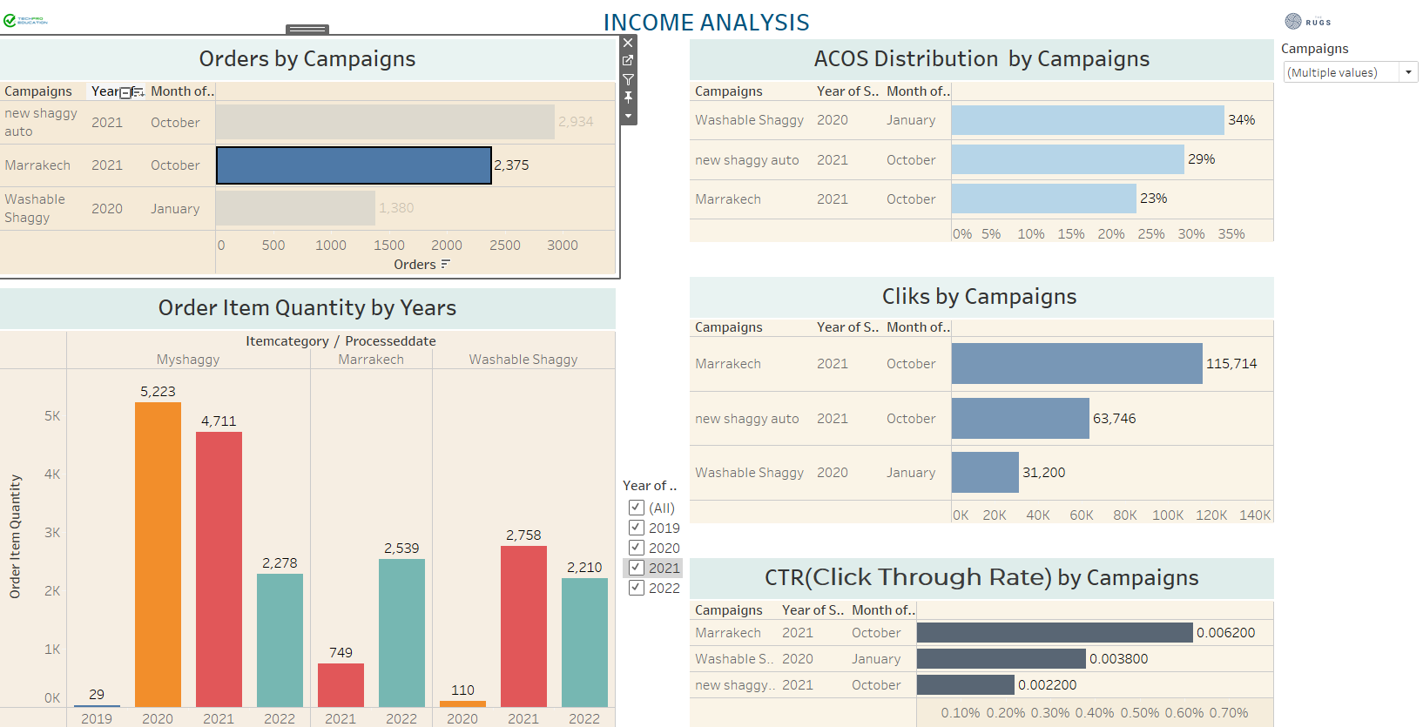

Figure 3-15

**Recommendation:** First of all, we need to be able to establish a relationship between the 'Sales and Amazon campaigns' tables so that we can measure the relationship between advertising expenditures and revenue. First of all, it is necessary to know which product category the advertisement application is applied to. Since this match could not be made properly, a relationship was tried to be established between the campaign names and the product category names in the sales table.

Therefore, it is evaluated that a healthy analysis can be made by adding the ASIN number in the "Sales" table to the "Amazon campaigns" table.

**Comment:** It is seen that the advertising campaign for the New Shaggy product was made in October 2021 and 2934 units were sold. When the sales volumes for the years are considered, it is seen that it lags behind the previous year and there is a decrease of approximately 50% in 2022 compared to 2021.

However, when the CTR ratio of the product is considered, it is seen that it is 0.0022 and the sales amount is 2934. Although we do not know the profit margin of the company, it can be said that the sales increased after the advertisement application.

4. Conclusions and recommendations

* We need to be able to establish a relationship between the 'Sales and Amazon campaigns' tables so that we can measure the relationship between advertising expenditures and revenue. First of all, it is necessary to know which product category the advertisement application is applied to. Since this match could not be made properly, a relationship was tried to be established between the campaign names and the product category names in the sales table. Therefore, it is evaluated that a healthy analysis can be made by adding the ASIN number in the "Sales" table to the "Amazon campaigns" table.
* In some products, it was observed that advertising did not have a positive effect on sales. For example, the My Shaggy model. It is considered that a review of the advertising strategy may be useful.
* It has been observed that Amazon and website sales rates are considerably higher than other platforms. In this context, it is thought that it may be useful to review sales strategies in order to increase the amount of sales on other online platforms.
* According to our data, the profit per product is 33 pounds in UK, 40 pounds in Germany, 53 pounds in Italy, 42 pounds in France and 55 pounds in Spain. Increasing sales to these countries will also increase profitability.
* According to the 6-month and 1-year forecast analyses, it is seen that the sales trend will continue upwards.
* When the total sales and order status in Amazon are evaluated, it is considered that it may be beneficial for the company to make sales on Amazon in other European countries.
* Sales are mostly made on the amazon platform. In this case, sales can be focused on sales platforms such as Etsy, Ebay.
* In general, sales are highest between June and September.